How Digital Controlled Power Supplies can improve the bottom line for your business

Most standard power supplies are controlled by analogue signals from passive components. Even the most sophisticated power systems have an extremely limited pathway for configuring and monitoring crucial parameters like fault data and adjusting output voltage.
But as the industry has developed greater need for power systems with greater accuracy and precision control in key adjustable operating parameters, many system designers have turned to digital controlled power supplies for on-the-fly monitoring and management of their crucial power systems.

PMBus
The PMBus standard for digital power management simplifies the configuration, sequencing and monitoring of power supplies, allowing for system designers to monitor and adjust the performance of their power systems digitally to improve the efficiency and flexibility of systems.
First released in 2005, the PMBus standard allows communication with a power converter by involving the use of a command set that layers upon a specially designed protocol using a physical layer of I²C Inter Integrated Circuit Bus.
PMBus is built upon the SMBus (System Management Bus), a single-end simple two-wire bus for lightweight communication. Where PMBus differs is its increased bus speed limits, blocks may include up to 255 bytes. These advancements from the SMBus protocol means PMBus can handle a wide array of power specific commands for power supply remote management.
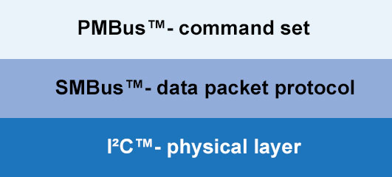
What this results in is easy and real-time control of specific parameters as defined by the PMBus command set. This includes around 200 commands, allowing for the configuration and sequencing of a wide array of power system functions. The commands can be loosely grouped into the following categories:
- Memory
- Turning the system on or off
- Controlling the output voltage
- Margining
- Configuration
- Monitoring and resolving warnings & faults
- Reading status
- Telemetry
- Inventory
- Manufacturer ratings

Benefits of Digital Power
During the development of systems, system designers can benefit from adjusting sequencing for reliable start-ups and collect and respond to fault data – reducing design cycles and overall development costs.
System engineers can benefit from real-time monitoring, control of system parameters and the ability to quickly resolve system errors and faults which can save your business from precious operational downtime.
For large power conversion systems, high level digital control affords it possible to manage power parameters reactively to meet the current demands of the system and the operation.
The ability for reliable remote management of power supplies improves the scalability of your business as PMBus allows for the power supplies to communicate with other companion chips. Any adjustment or modification needed can be made a simple software routine and transmitted digitally to multiple systems.
Other benefits of digital power include:
- Wider stable operating ranges
- Tighter unit-to-unit repeatability as through digital control, designers can eliminate loop inconsistencies caused by analogue components
- Configurations can be downloaded
- Reducing system cost as virtual power components can be formed
- Automated adjustments result in better consistency

Products
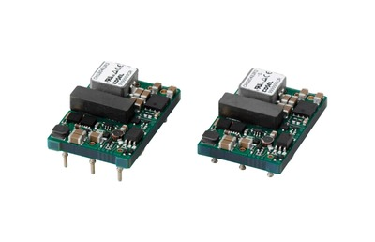
One of the ultra-compact DC-DC converters making full use of the PMBus standard is the CHS80 from Cosel. Alongside a built-in remote on and off feature, the use of PMBus allows this converter to be managed, configured and monitored remotely through digital control.
As a DIP package, the CHS Series is available in industry standard brick sizes for easy installation onto a PCB – making it ideal for use in the telecommunication market. This compact power converter also includes built-in overcurrent, overvoltage and thermal protection circuits for added redundancy and safety.
Through its PMBus interface, the CHS80 can communicate with other chips on a board, allowing system designers to create reactive power management schemes through communications from other chips in a system.
With efficiency of up to 95%, and a wide operating temperature range of -40 to 85 degrees Celsius, the CHS80 is perfect for designers looking for an adaptive and versatile power supply delivering up to 80W of power.
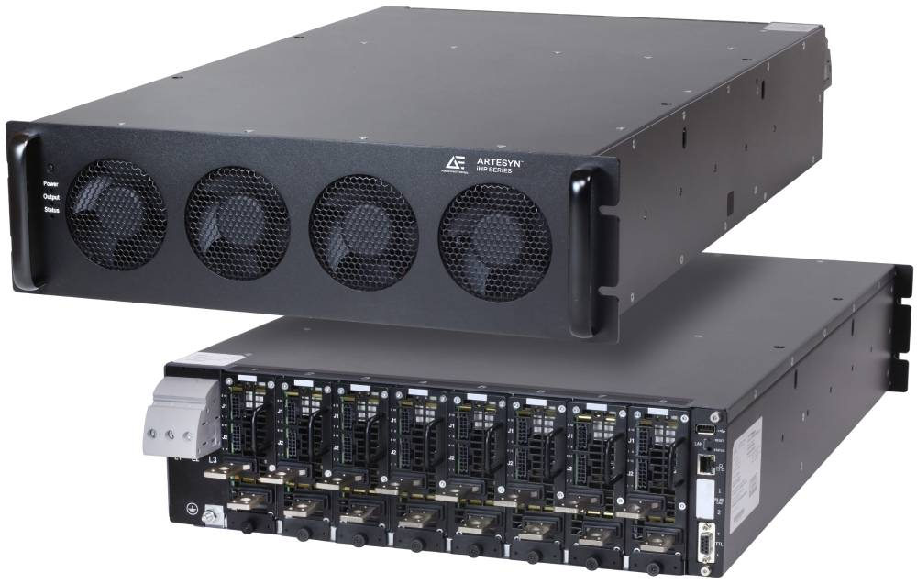 The Artesyn iHP is where digital control is taken to the next level. For system designers looking for complete control and sequencing of key parameters in a demanding power level application, Artesyn’s state of the art precision high power system offers the remote control needed for true central management of a large, sprawling power network.
The Power Pro configurable GUI allows end users to seamlessly control and monitor all functions, including monitoring fault data, system temperature and set detailed routines.
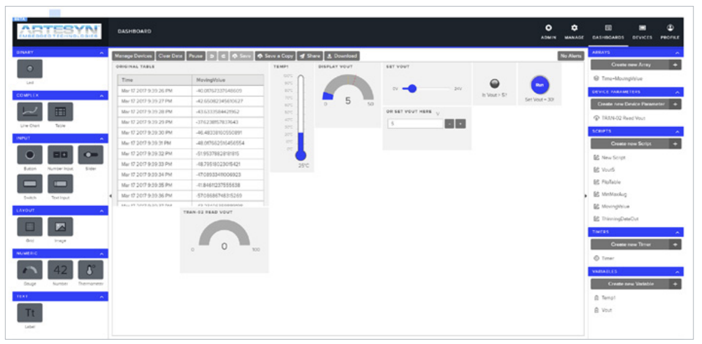
Where Artesyn’s integration of the I2C standard improved on the precedents set by the use of PMBus is with its GUI, system designers can use a graphical script creation engine allowing for user-friendly control and maintenance.
Multiple iHP systems can be controlled from one central controller through a remote GUI accessed on a local network, furthering the benefit of added scalability mentioned earlier in the article.

In the name of Precision
Digital control is perfect for any application where rapid, on-the-fly adjustments need to be made to multiple system parameters. Beyond output voltage and monitoring system temperatures, bespoke and open standards like PMBus allow for the flexibility in managing key fault data and creating predictive power sequences.
Digital power has its place in high-power critical applications (like affording the pinpoint power precision needed for medical equipment) as much as it’s useful for low-power applications where the added efficiency and development time and cost savings are more evident.
Affordable power modules like the CHS80 show that digital power has its home in low-cost and compact applications demonstrating that digital control supplies have the capable rate of adoption to become the dominant method of power management in the power supply industry.
Rapid and flexible configurability makes our digital control range the perfect place to start to cut the development, deployment and operational costs of your next system.

